# Virtual 7.1 software installation instructions

# 一、Version description:

**File name: xx Virtual 7.1 Audio.exe Version: V5.3.2016.10**

**Compatible: WIN XP, WIN7 32Bit/64Bit, WIN8.x, WIN10**

*This installation and use instruction is based on WIN10. You can install without connecting the USB headset device, or restart the computer or re-plug the USB headset after the installation is complete.

# 二、 Installation introduction:

2.1. This release only supports specific VIDs and PIDs for USB headsets. Use EEPROM software to upgrade and replace VID\PID; (please make sure that the playback device and recording device of the computer have been switched to USB headphones)

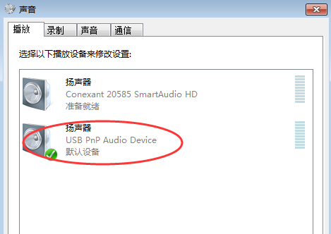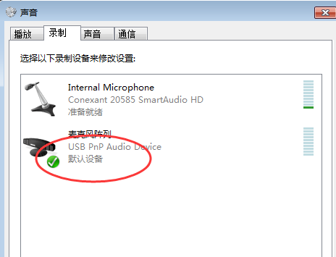

2.2. Before installation, there is no need to connect a USB headset device. Be sure to exit anti-virus software such as 360 Security Guard, QQ Manager and other anti-virus protection software; the protection software will prevent the installation of the virtual 7.1 software process, resulting in abnormal software;

2.3. Double-click the software to start the installation: (Please right-click on some systems above WIN7--->Install as administrator.)

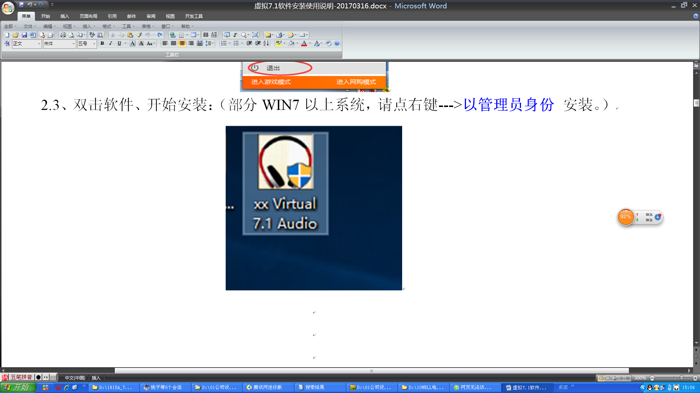

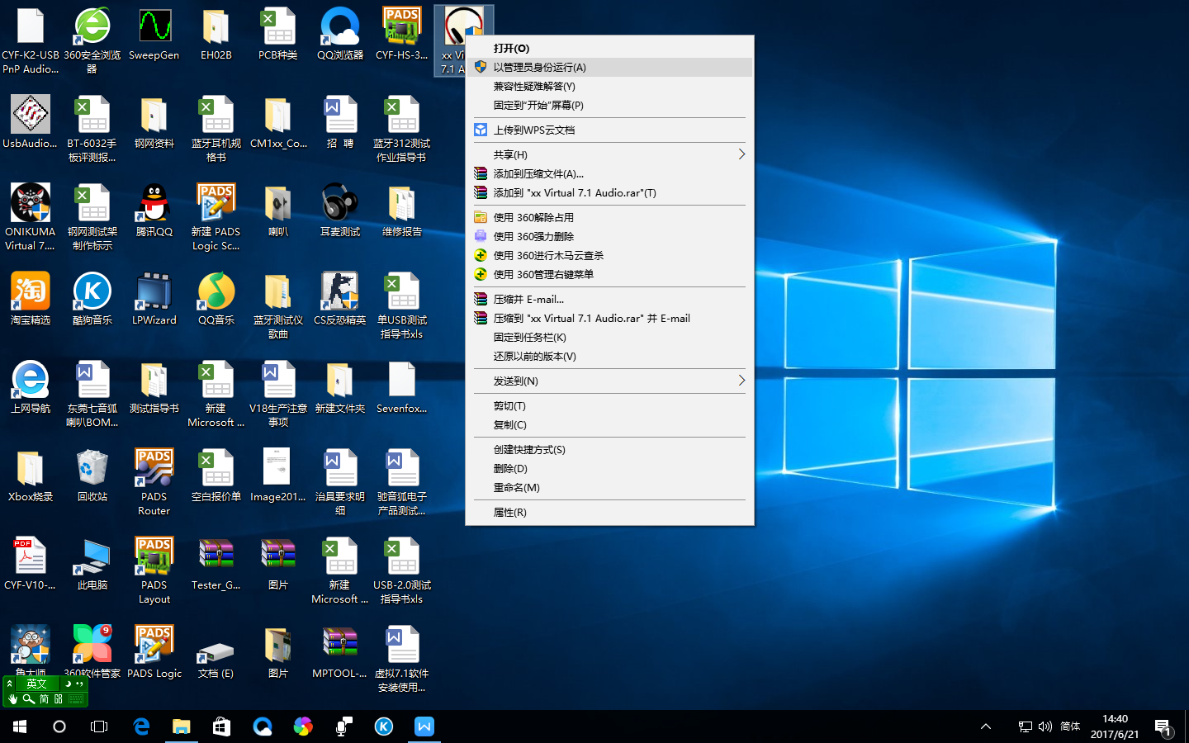

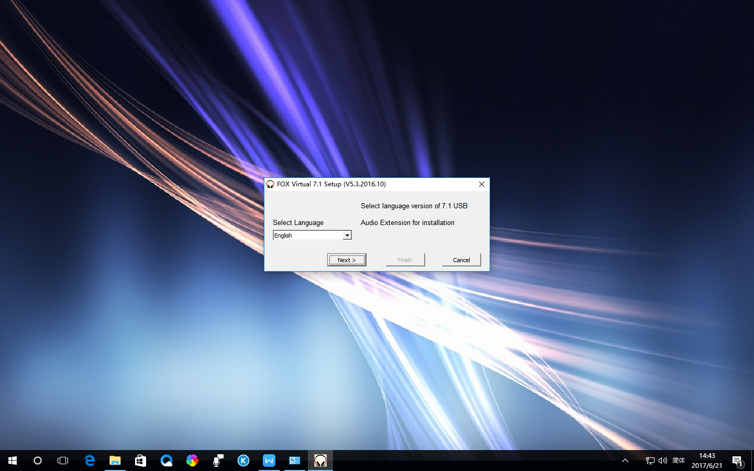

2.4. During the installation process, if the protection software such as 360 Security Guard is not turned off, the installation will be blocked, please select "Allow". Avoid process installation failures. (If it is blocked, please exit the protection software and reinstall it.)

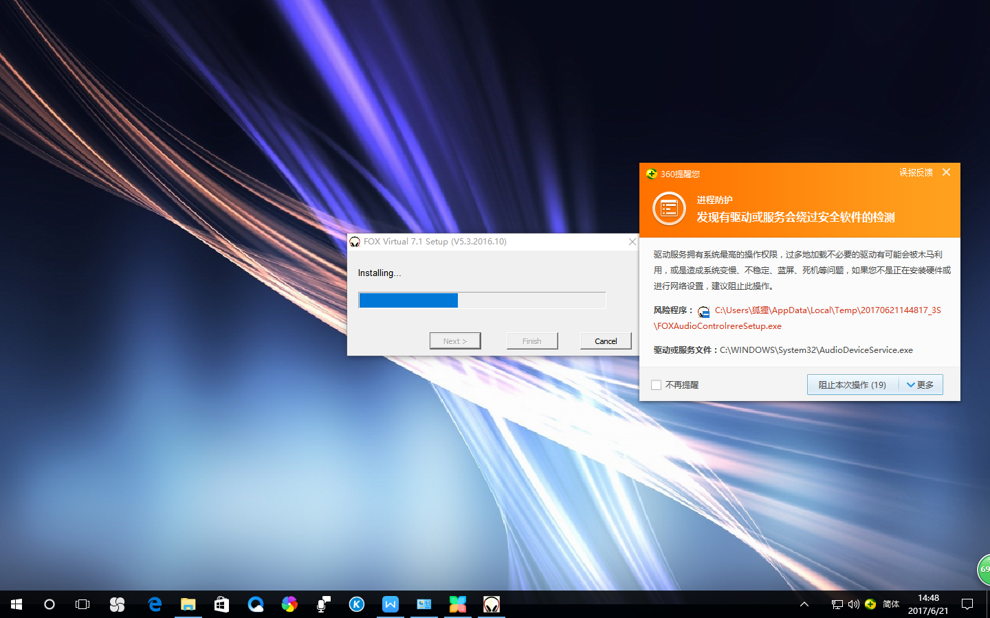

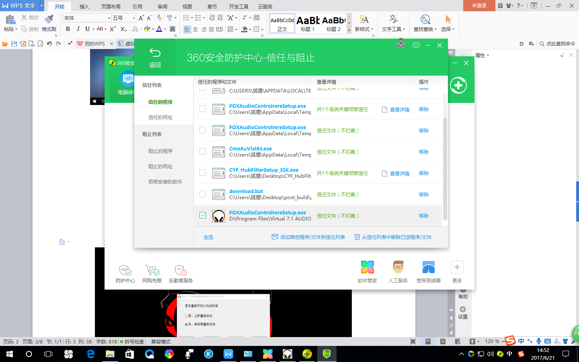

2.5. After the installation is complete, please choose to restart later, and click Finish to complete the installation. (This version does not require restarting the computer)

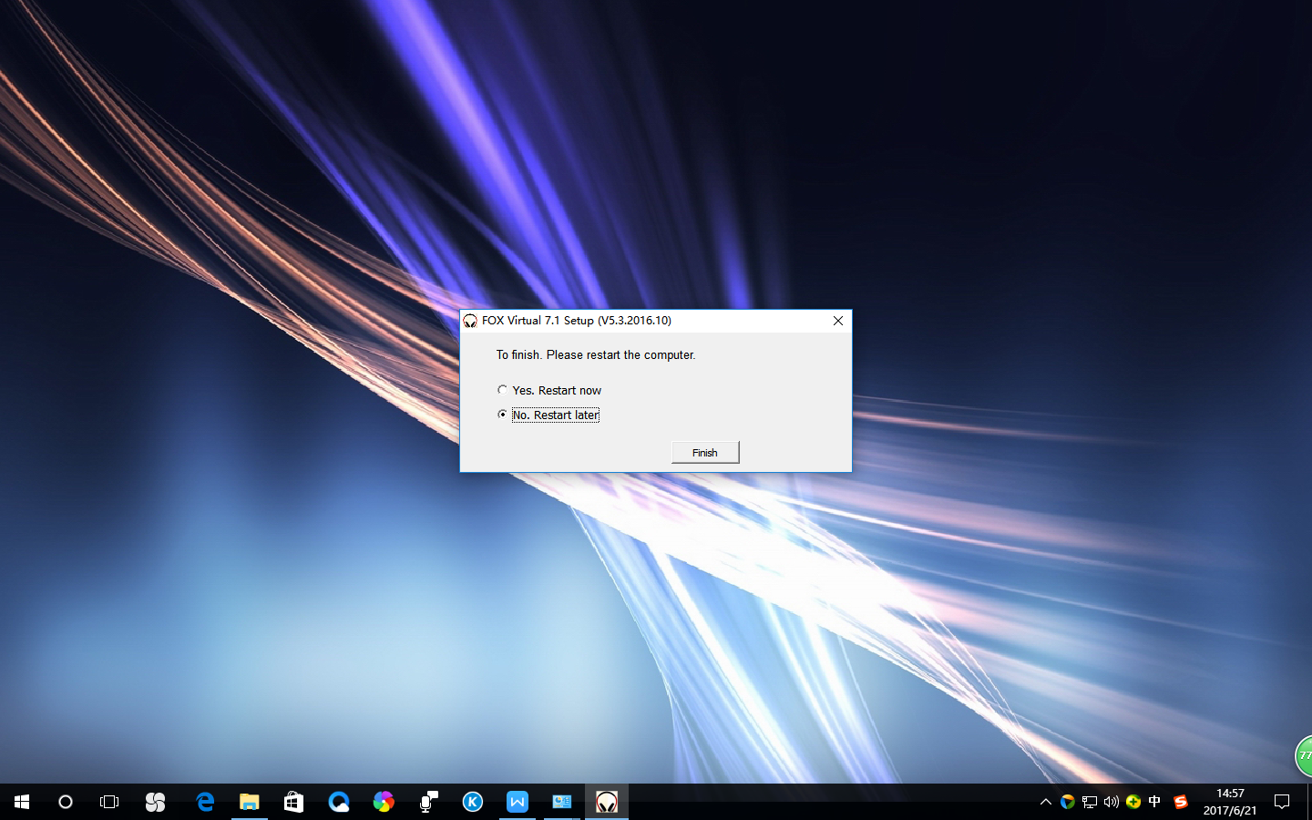

2.6. After completion, the virtual 7.1 icon will appear in the lower right corner of the computer; the process of the virtual 7.1 software will appear in the system "task manager".

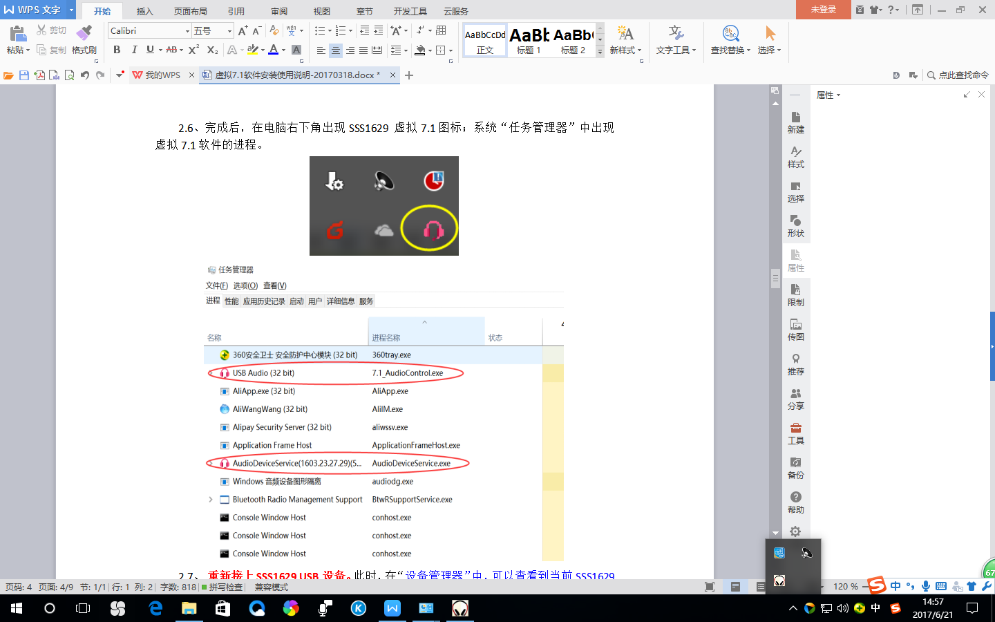

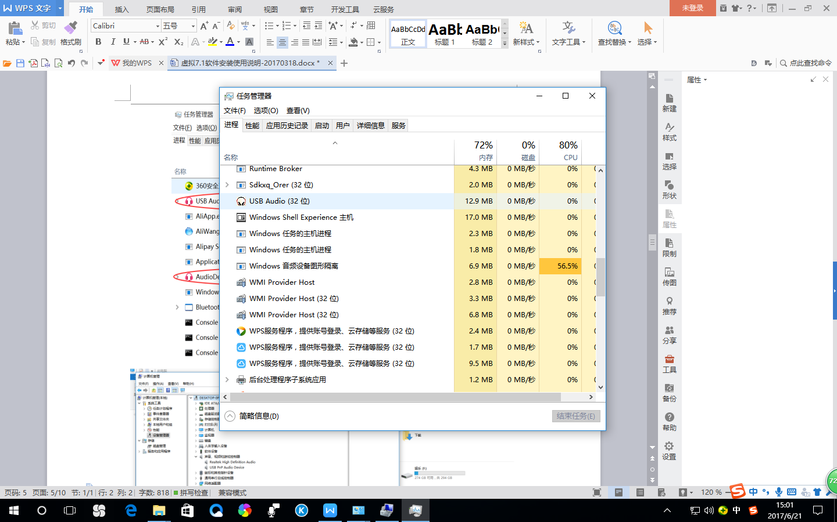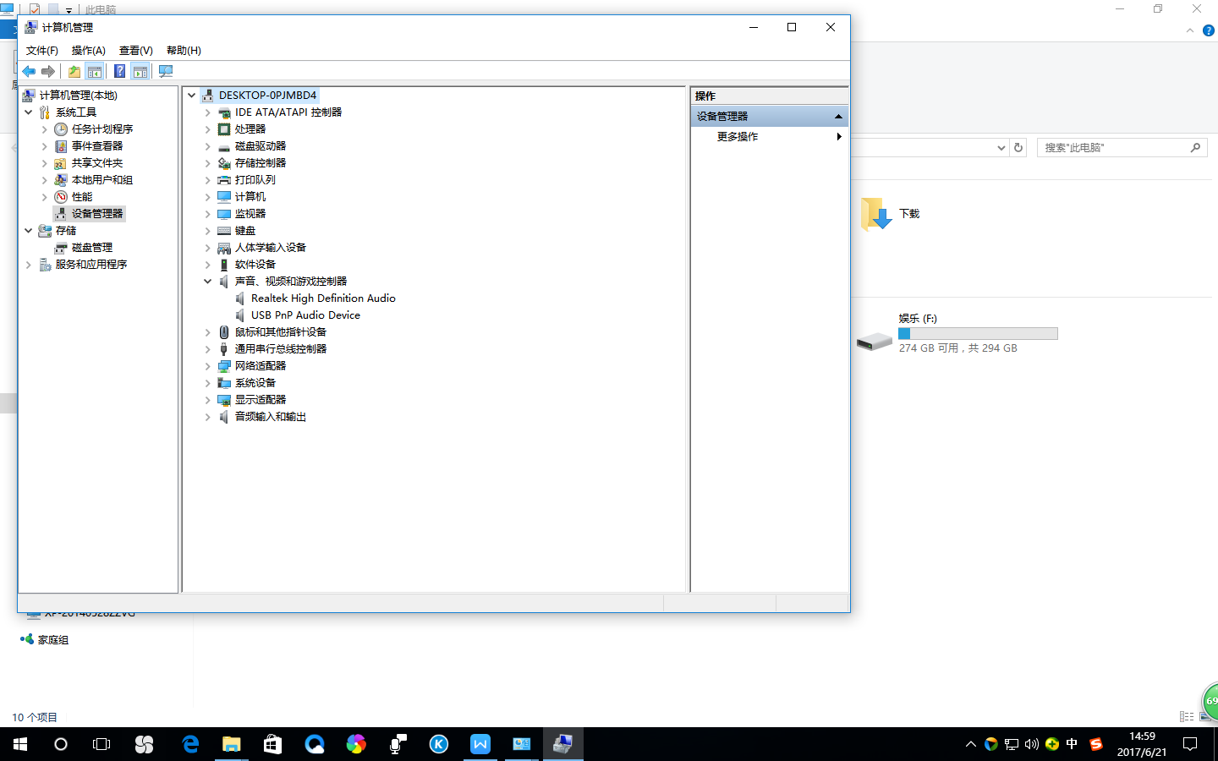

2.7. Reconnect the USB headset device. At this point, the driver information of the current USBPnP Audio Device device can be viewed in the "Device Manager" as shown in the figure below, which means that the driver installation is successful.

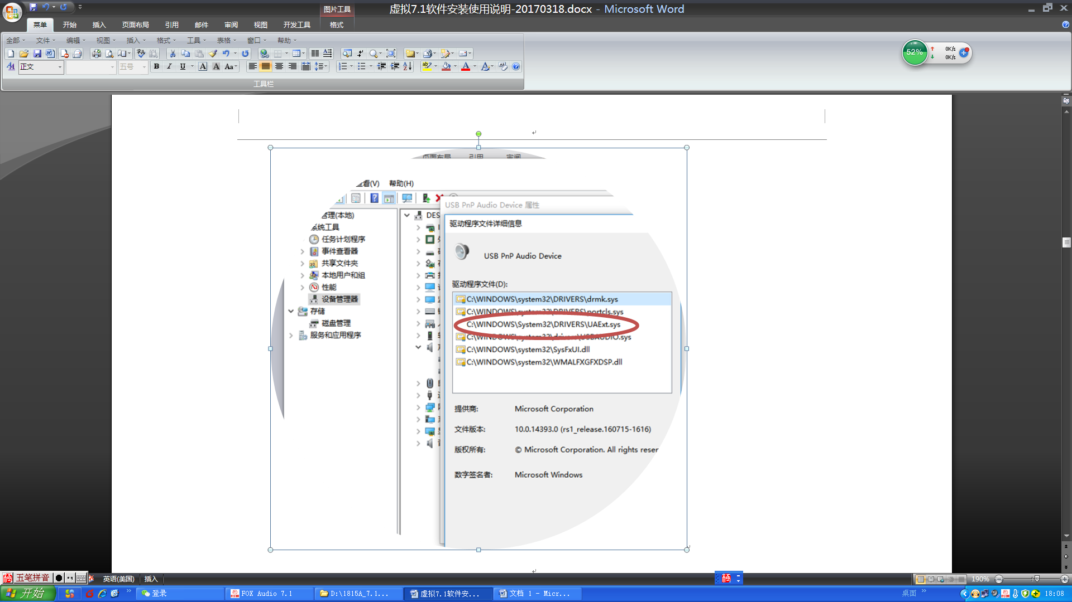

# 三、Software introduction：

Virtual 7.1 software has five main interfaces: "EQ, Effect (ambient sound), Mic (microphone), Virtual7.1 (virtual 7.1)".

exist:

EQ: 4-band setting, EQ adjustment effect of synchronous monitoring frequency band, 3D sound effect and current USB headphone device

Effects: Simulate four live effects, cinema, reverb, opera mode, DJ mode;

Mic: microphone function monitoring, mute switch, etc.;

Virtual7.1: Demonstration of virtual 7.1 effects.

3.1. Open the software, the default EQ interface, as shown below.

If the interface is in English, when "Device Active" is displayed, it means that the current software has detected a USB device. **USB headset must be connected to use**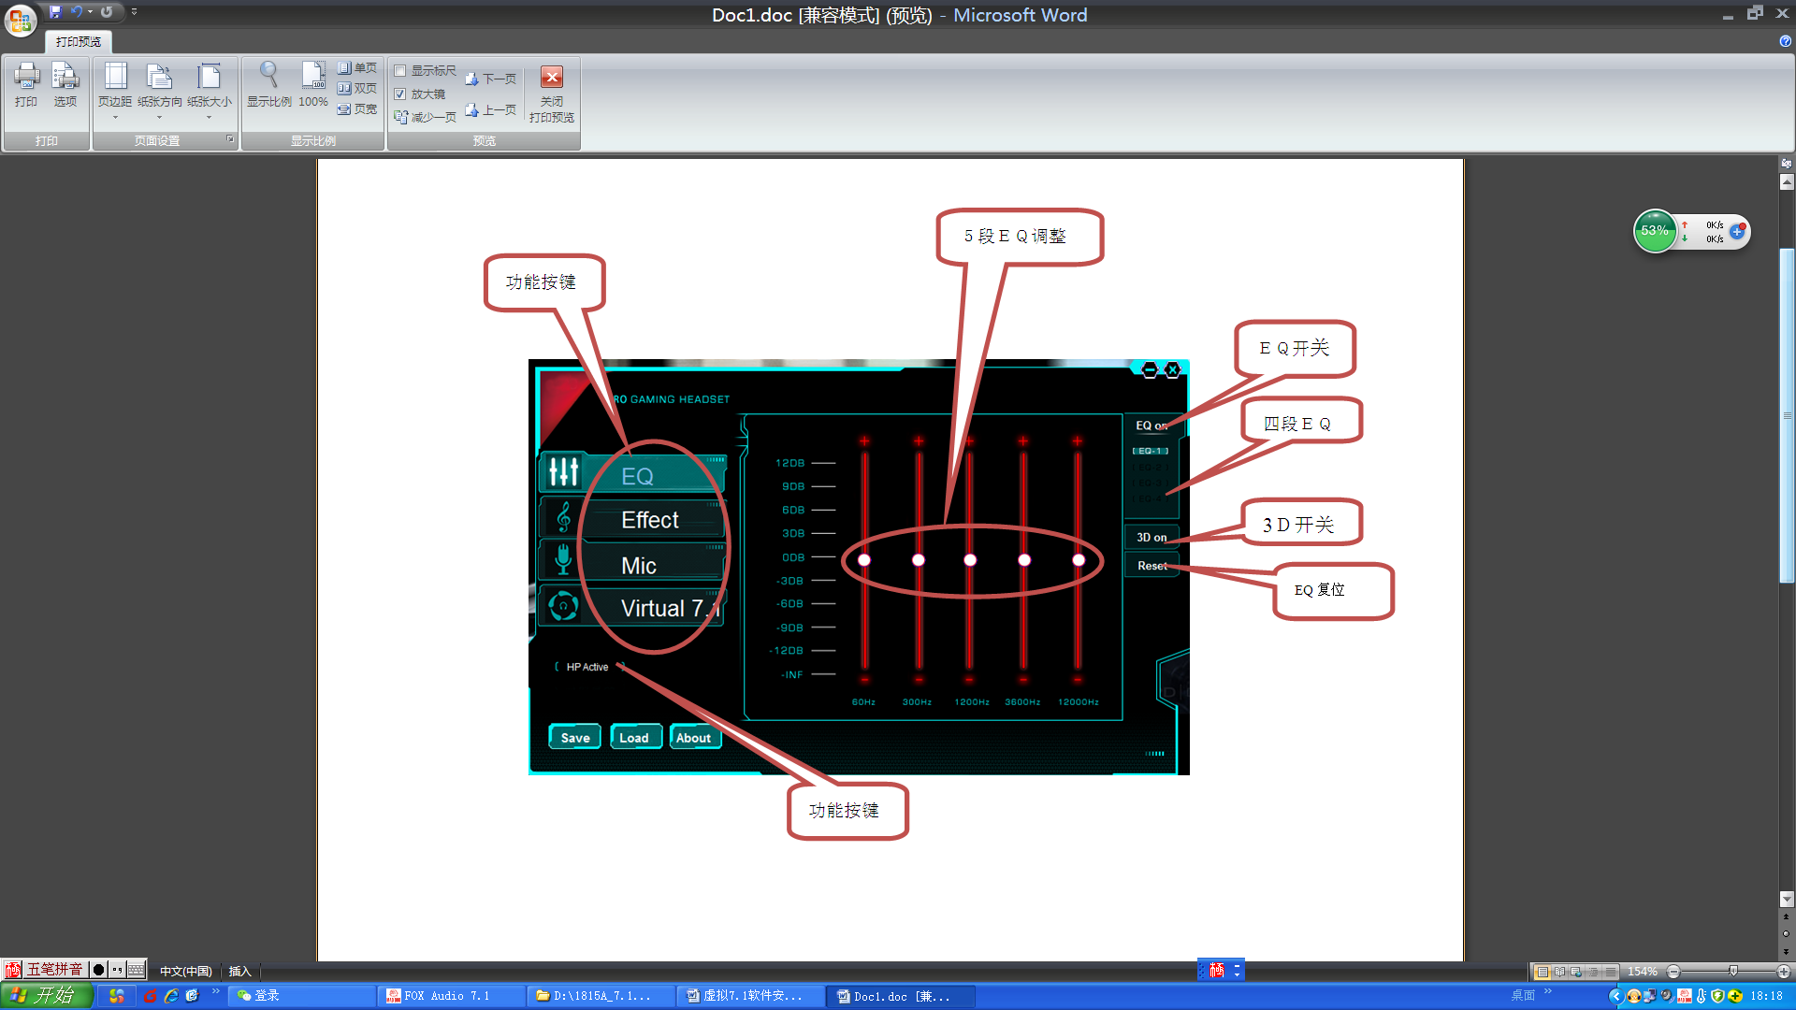

3.2, Effect field effect function demonstration:

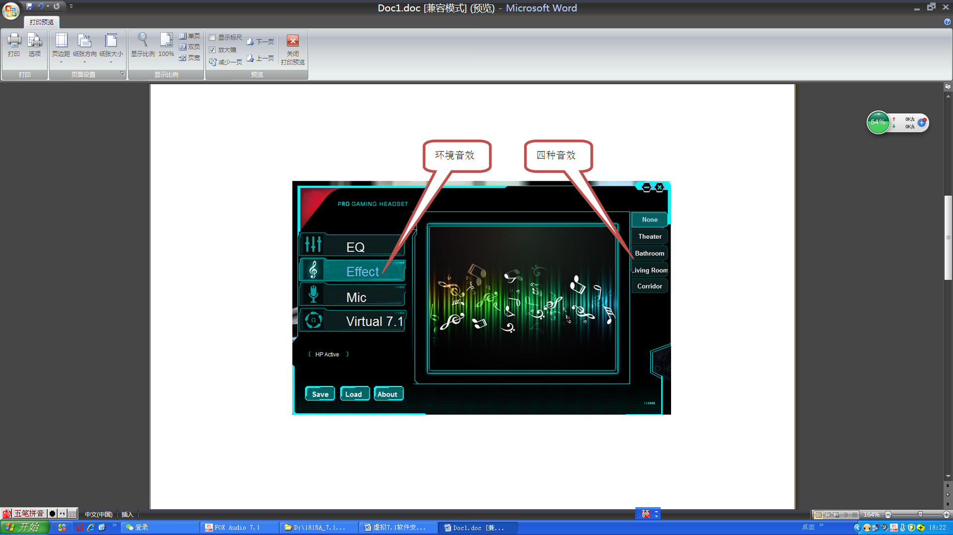

3.3. Mic microphone function demonstration:

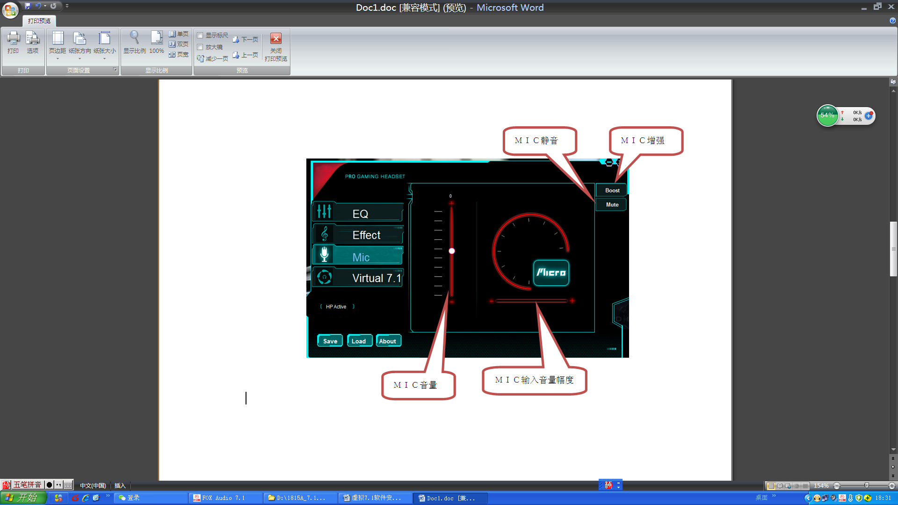

3.4, Virtual 7.1 Virtual 7.1 function demonstration:

Button function introduction:

Virtual7.1: Virtual switch key

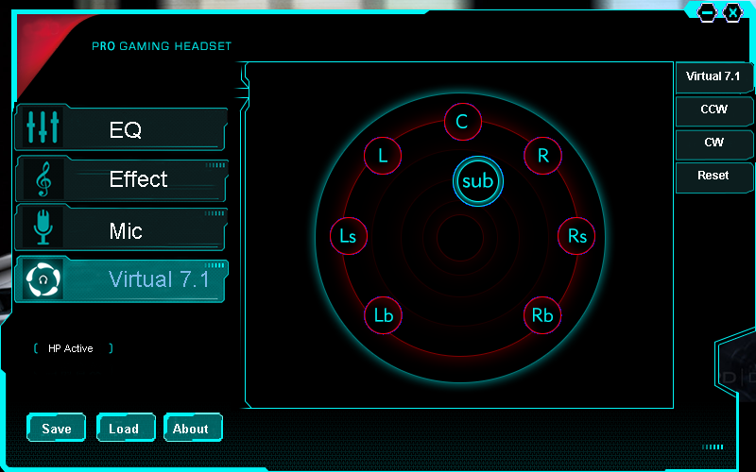

7.1音效功能键

正转或反转音场

# 四、uninstall：

1. Unplug the connected USB device, select uninstall program, and uninstall. (Different systems have different uninstall methods, you can uninstall according to the normal operating system software uninstall method.) As shown in the figure below, click Uninstall to uninstall

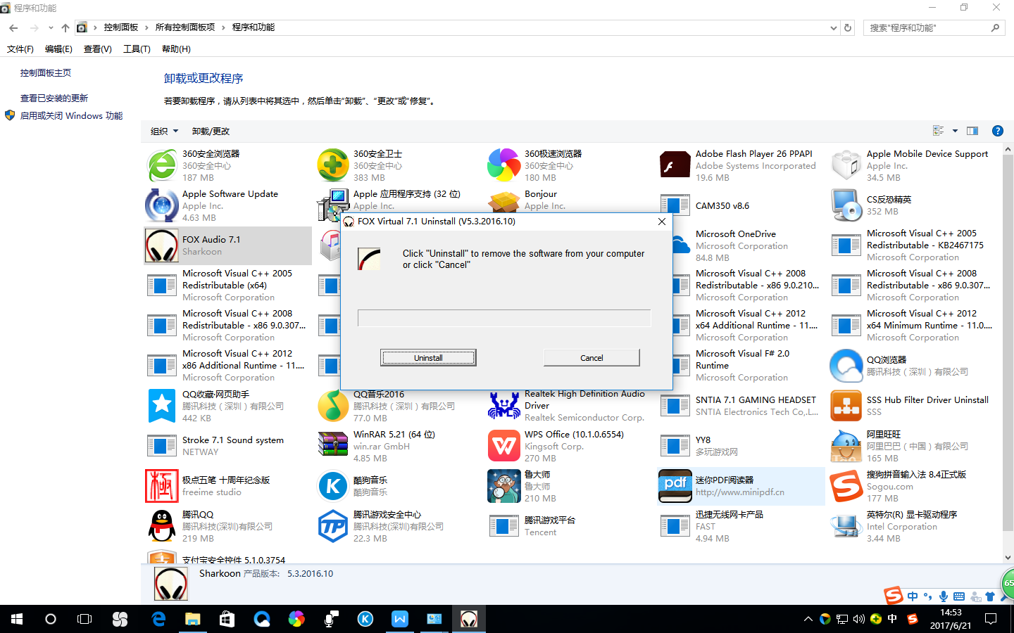

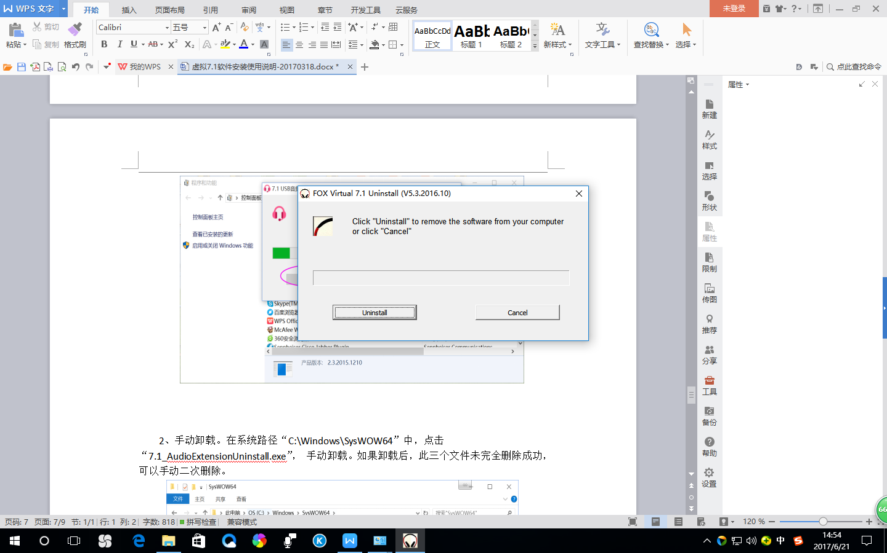

**Note: For different client software, the above icons or some client software names and functions will be slightly different, but the operation methods are basically the same.**